**5.0. Mathematics for Machine Learning - Introduction**

**What is the importance of mathematics when it comes to machine learning?**

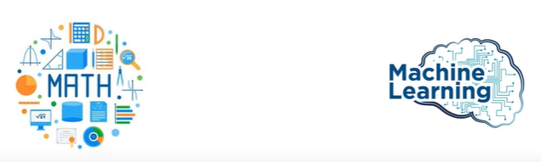

**Importance of math in Machine Learning.**

* If you want to master the machine learning (or) deep learning understanding of maths is required.

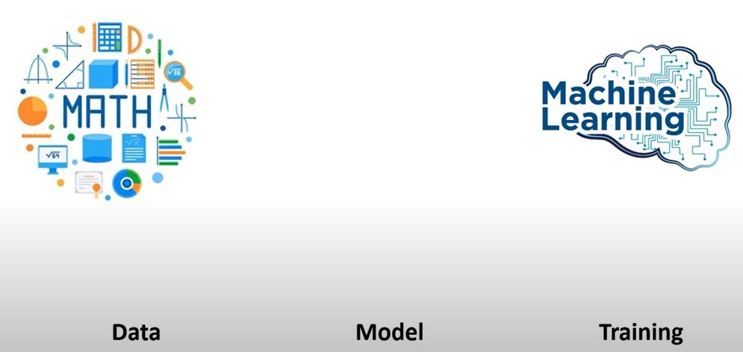

* When we talk about machine learning there are 3 main pillars to it.

1. Data
2. The machine learning Model and
3. Training machine learning model.

* When it comes data we have to understand data better, for understanding the data we need to use some statistical measures.
* All the computations are based on linear algebra, so understanding of linear algebra becomes very importance and also several statistical concepts are also integrated in lot of machine learning model.

In machine learning we will be dealing with 4 subfields of mathematics and these four subfields are very important when it comes to machine learning.

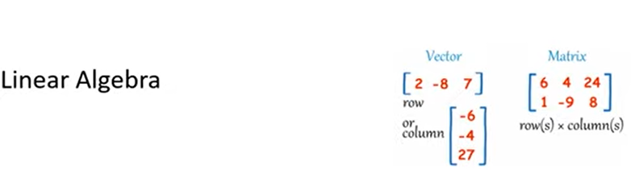

1. **Linear Algebra:**  So in linear algebra we will be dealing with vectors and matrix. The understanding of vector and matrix is very important because all the computations are based on vectors and matrix. So we have dataset very similar to matrix and all the computation that we do in matrix. This is where linear algebra is used.



1. **Statistics:**

* Statistics is also very helpful to understand our data.
* What is the mean value of different columns, what is the standard deviation and also we can see if we have any outliers in our dataset.
* It is very useful in data analysis part and also several machine learning model are built on top of this statistics.
* Statistics have majorly categorized into two types:

Descriptive statistics

Inferential statistics.

1. 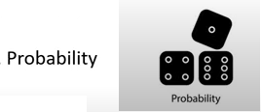**Probability:**

Probability is all about likelihood of some decision. Let’s say we are going to predict whether a person has diabetes or not. So the machine learning model will give us the probability that this person has diabetes or doesn’t have diabetes this is all based on probability concepts so this understand is very important.

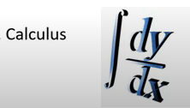

1. **Calculus:**

There are two types of calculus

1. Differential calculus
2. Integration calculus

**Differential calculus** is all about splitting the data into small pieces and seeing what is the change is going on this data.

**Integration Calculus:** Integration is all about integrating small pieces into large amount so this particular calculus is very important when it comes to optimizing our model.

**Linear Algebra – Vector Mathematics for Machine Learning**

In this we are going to learn mathematics behind machine learning.

* Linear algebra is all about dealing with linear equation.
* Built blocks of linear algebra are vector and matrix.
* There are 3 approaches which include

1. Physics based approach for understanding vectors
2. Mathematics based approach
3. Computer science based approach

**Vectors – Physics based approach**



There is a car we want to measure physical quantity for a moving car. Speed is a physical quantity by which we can determine how slow or fast an object is moving.

Speed = 50 km/hr

It is scalar quantity because when we talk about speed we don’t mention direction in which car is moving which tells the magnitude of the speed.

Here the magnitude is nothing but 50km/hr. hence it is a scalar quantity.

**Example -2:**

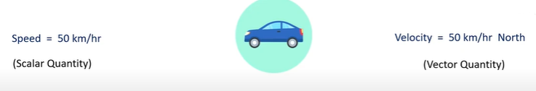

When we talk about velocity of a car it tells 50km/hr. in the north direction so here we can see that we have both magnitude as well as direction in which car is moving this is an example of vector quantity.

**Vectors – Mathematical Approach:**

Vectors have:

1. Magnitude
2. Direction

Let’s see we have coordinate system x - axes and y- axes

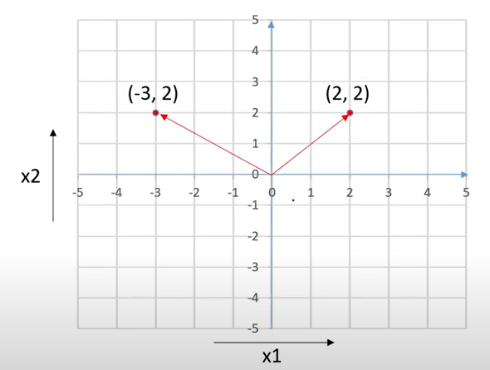

* These points are nothing but vectors.
* Vectors are all about list of coordinate of those particular points.
* If we draw an arrow from this origin which is (0,0) and (-3,2) we will get the vectors.
* One vector is (2,2) another vector is (-3,2).

Let’s consider (2,2) as first vector which start from origin and ends in this points i.e (2,2). This is an example of an vector . This vector has some magnitude the length it has in this particular graph.

And the magnitude of second vector is greater than of the first vector and we can see it has some kind of direction.

* It is not horizontal direction it is inclined to some magnet.
* Magnet means with nonzero inclination.

Vector 1 🡪 (2,2) we can also represent as vector 1 🡪 2i +2j.

* Two vectors can have same magnitude but can have different directions.
* Similarly two vectors can have same directions but different magnitude.

**Magnitude of vector:**

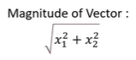

Calculate the magnitude of vector 1 i.e (2,2)

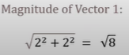

* Calculate magnitude for vector 1(-3,2).

As we know we can have direction for vector



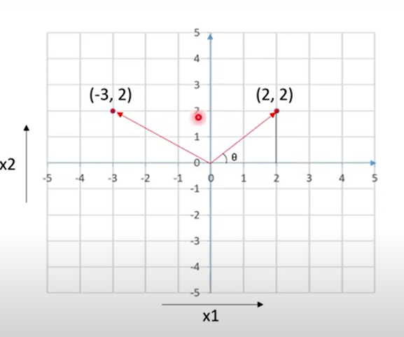

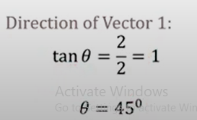 Tan inverse of 1 is 45

**Computer Science Approach:**

* Scalar is nothing but a number it can be an integer or it can be a float

We just place a value.

* When it comes to vector it can be a list of numbers.
* It is similar to an array

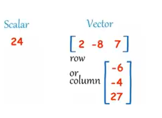

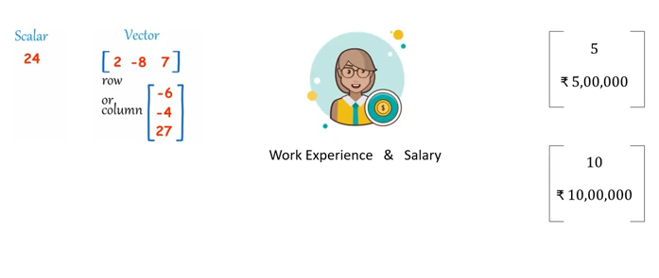

**Vector Operations:**

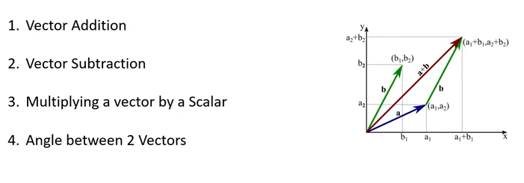

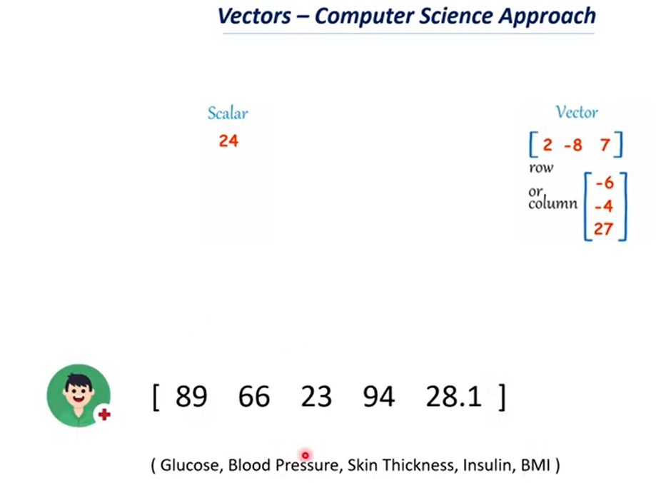

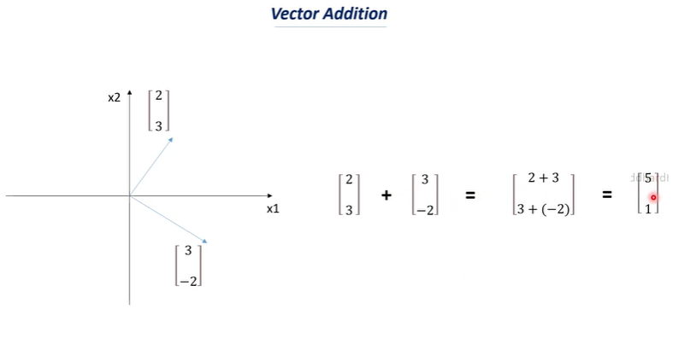

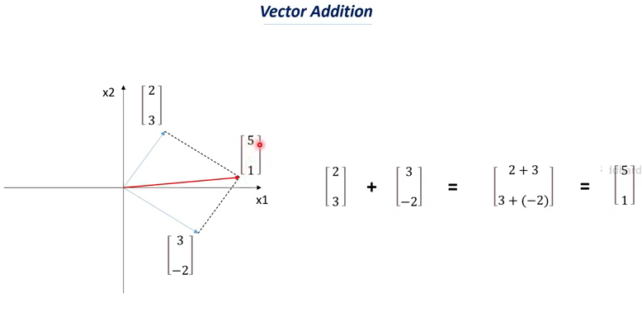

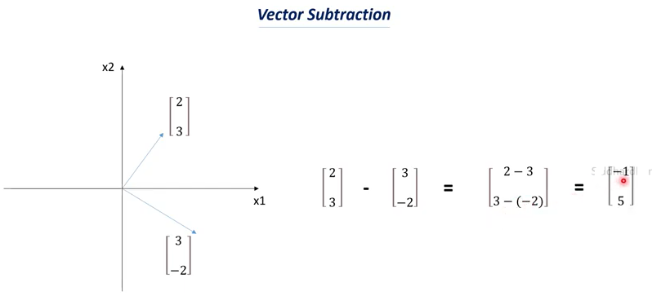

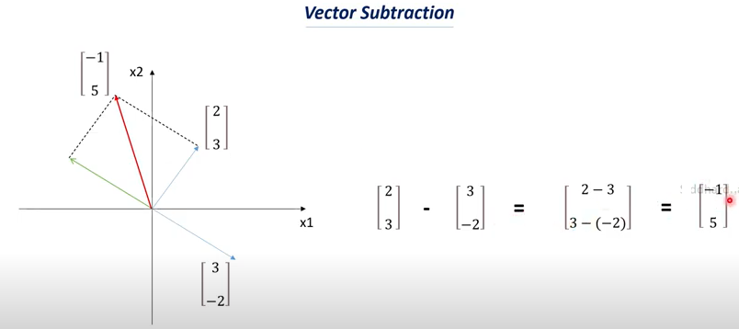

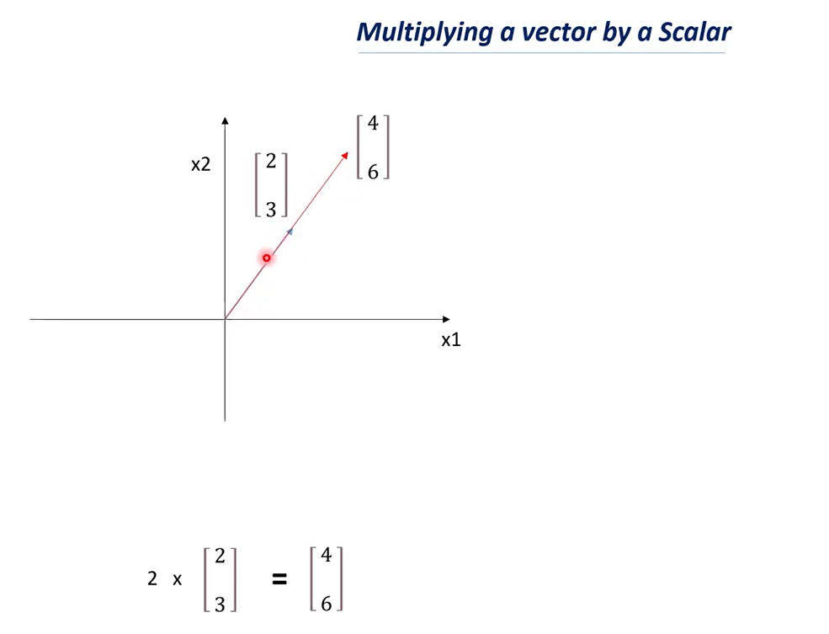

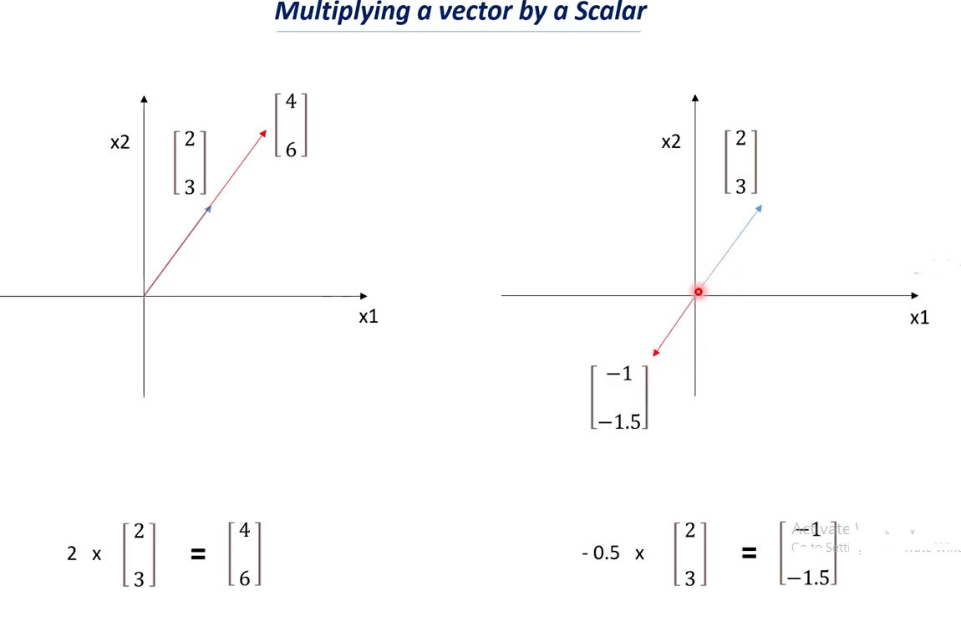

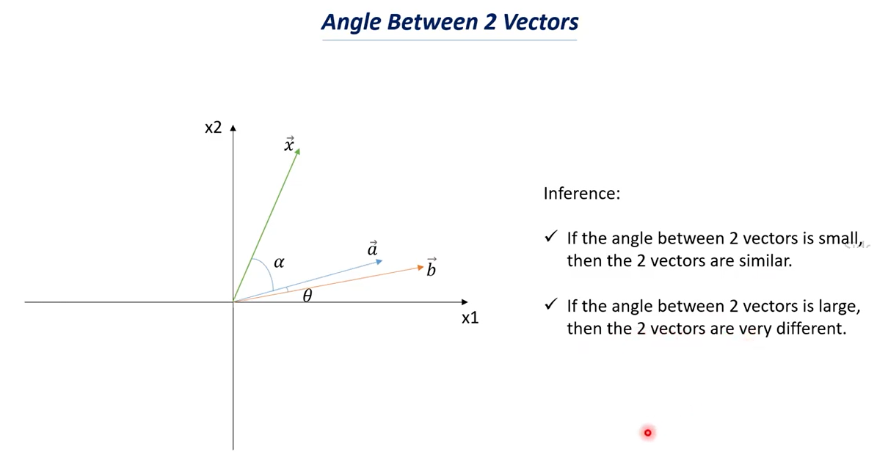

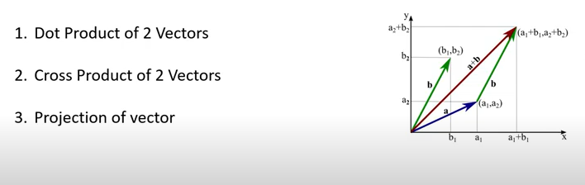

Note:

* Dot product is just specifying dot between two vectors.
* Here both the coordinates should be multiplied.
* When we perform dot product of two vectors the resultant will be a scalar.
* Scalar is nothing but numerical value or a constant it is not a vector.
* If you add two vectors or if you subtract two vectors resultant will be vector where as if we perform dot product the resultant will be scalar.

